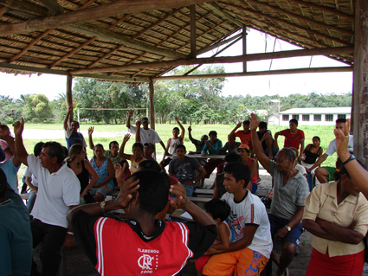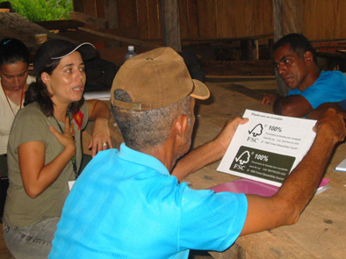

**FSC PROCEDURE**

FSC Internal GOVERNANCE

Due diligence evaluation for the association with FSC

FSC-PRO-10-004 (V1-0) EN



|  |  |
| --- | --- |
| **Title:** | Due diligence evaluation for the association with FSC |
| **Document reference code:** | FSC-PRO-10-004 (V1-0) EN |
| **Scope:** | FSC internal |
| **Approval date:** | September 2011 |
| **Contact:** | FSC International Center |
| **E-mail for comments:** | policy.standards@fsc.org |
| © 2011 Forest Stewardship Council, A.C. All rights reserved.  No part of this work covered by the publisher’s copyright may be reproduced or copied in any form or by any means (graphic, electronic or mechanical, including photocopying, recording, recording taping, or information retrieval systems) without the written permission of the publisher. | |

**Due diligence evaluation for the association with FSC**

FSC-PRO-10-004 (V1-0) EN

|  |
| --- |
| The Forest Stewardship Council® (FSC) is an independent, not for profit, non-government organization established to promote environmentally appropriate, socially beneficial, and economically viable management of the world's forests.  FSC’s vision is that the world’s forests meet the social, ecological, and economic rights and needs of the present generation without compromising those of future generations. |

**Contents**

A Scope

B Effective date

C References

D Terms and definitions

1 General Principles

2 The Due Diligence Process

3 Collection of information

4 Risk assessment

5 Mitigation of the risk

**A Scope**

The objective of this document is to provide a transparent internal procedure for FSC to ensure the consistent implementation of a due diligence process to minimize the risk of establishing a formal relationship with organizations or individuals which are not in compliance with the requirements of the *Policy for the Association of Organizations with FSC.*

**B Effective date**

This procedure becomes effective upon approval.

**C References**

The following referenced documents are indispensable for the application of this document. For undated references, the latest edition of the referenced document (including any amendments) applies.

*FSC-POL-01-004 Policy for the Association of Organizations with FSC*

*FSC-STD-01-005 FSC Dispute Resolution System*

*FSC-PRO-01-009 Processing Formal Complaints in FSC Certification Scheme*

*FSC-LEG-01-004 Policy for Association self-declaration form*

*FSC Membership Work Instructions*

**D Terms and definitions**

For the purposes of this procedure, the terms and definitions provided in *FSC-POL-01-004 Policy for the Association of Organizations with FSC, FSC-STD-01-005 FSC Dispute Resolution System*, and the following apply:

**Applicant:** organization or individual that wants to enter into a formal relationship with FSC as member, certification body, license holder or partner.

**Due diligence**: is a precautionary investigation of a business or person prior to signing a contract.

**Rapid appraisal**: method to gain qualitative information about someone or something in a fast and succinct way.

**1 General Principles**

1.1 Before entering into an association with an organization or individual, FSC shall conduct a due diligence evaluation according to the requirements specified in this document to evaluate the existence of objective evidence that an organization is directly or indirectly involved in any of the unacceptable activities as listed in Part I Clause 1 of FSC-POL-01-004.

1.2 In cases of doubt or high risk, the burden of proof shall be on the organization or the individual to demonstrate conformance to FSC-POL-01-004.

1.3 FSC shall only enter into an association with organizations or individuals that have passed the due diligence process.

**2 The Due Diligence Process**

2.1 The due diligence process includes three elements inherent to risk management:

1. Collection of information;
2. Risk assessment;
3. Mitigation of the risk identified.

**3 Collection of information**

3.1 Information on the applicant regarding the involvement in any of the unacceptable activities as listed in Part I Clause 1 of FSC-POL-01-004 shall primarily be collected by requiring all applicants to declare their involvement in writing prior to entering into an agreement with them.

NOTE: For this purpose FSC has developed a self declaration form (FSC-LEG-01-004).

3.2 In addition to the self-declaration, additional sources of information shall be evaluated for the following applicant categories:

1. Applicants for FSC membership (by the Membership Unit or the responsible Network Partner);
2. Applicant business partners (by the Key-account managers).
3. Applicant license holders that had their license or certificate withdrawn previously.

3.3 For the applicant categories as listed in Clause 3.2, the responsible operations unit of FSC shall conduct a rapid appraisal on the involvement of the applicant in any of the unacceptable activities by consulting:

1. Internet sources;
2. FSC Regional Offices (in the relevant region);
3. FSC National Offices (in the relevant country);
4. Reference calls (for applicant business partners only).

**4 Risk assessment**

4.1 The signed self-declaration shall satisfy Clause 1.3 for all applicants that are not explicitly listed in Clause 3.2 and the agreement can be signed.

4.2 If the additional information collected does not indicate any direct or indirect involvement of the applicant in any of the unacceptable activities the agreement can be signed.

4.3 If the additional information collected does indicate a direct or indirect involvement of the applicant in an unacceptable activity, the applicant shall be requested to comment on the findings in writing and to explain its involvement. An agreement shall not be signed as long as the issue is pending.

**5 Mitigation of risk**

5.1 Applicants that have passed the due diligence process are eligible to enter into an agreement with FSC.

5.2 Applicants who provided an explanation on their presumed involvement are eligible to enter into an agreement with FSC if the explanation satisfies the FSC Executive Director.

5.3 Applicants who admit their involvement in unacceptable activities or whose explanation did not convince the FSC Executive Director are not eligible to enter into an agreement with FSC. They shall receive a written statement on the reason they disqualify for association and the conditions that must be fulfilled to become eligible to associate with FSC. The notification shall include the information that the applicant has the right to formally appeal the decision in line with FSC-PRO-01-005 within thirty (30) days after notification of the decision.

5.4 If the applicant appeals the decision, FSC shall process the appeal according to FSC-PRO-01-005.